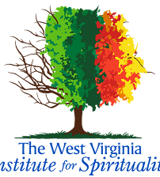
The West Virginia Institute for Spirituality
1601 Virginia Street East, Charleston, WV 25311
Sr. Cheryl Clemons, O.S.U., Ph.D., WVIS Executive Director

SPIRITUAL DIRECTION CERTIFICATION TRAINING PROGRAM
APPLICATION FORM

Name:
Mailing Address:
E-mail Address:
Cell Phone (or best phone):

Provide Educational Background:

With whom have you discerned your readiness for training as a spiritual director?

Spiritual Direction:
- Are you presently receiving individual spiritual direction?
- If yes, how long have you been in individual spiritual direction?
- Have you made a 30-day silent Ignatian retreat?
- If yes, please indicate when (date) and where (location)
- Have you completed the 19th Annotation Retreat?
- If yes, please indicate when (start-finish date)

Write about yourself including your life journey – what has led you to this decision? Describe your retreat experience. What gifts do you bring to the spiritual direction ministry? (Please use as much space as needed).

Please return this completed form to the attention of: Sr. Cheryl Clemons, O.S.U., Ph.D., at Exec.Director@wvis.org by May 1, 2026.

NOTE: This application form, letters of recommendation, and your meeting with Sr. Cheryl must be completed by August 1, of the year you plan to begin classes in September.

Questions, please email Sr. Cheryl or call 304-345-0926

